# Exercises

1. **Edit the code below so**
   * the program repeatedly asks the user for two numbers, adds and displays them (using the sub routine) - **until** the user enters two 0’s.

//subroutines and passing parameters

**public** **class** subroutines03A {

**public** **static** **void** main(String[] args) {

//send 2 actual parameters

*addTwoNumbers*(152, 3732) ;

**int** n1, n2;

TextIO.*putln*(" enter a whole number ");

n1 = TextIO.*getInt*();

TextIO.*putln*(" enter a whole number ");

n2 = TextIO.*getInt*();

//send 2 actual parameters

*addTwoNumbers*(n1, n2) ;

TextIO.*putln*(" enter a whole number ");

n1 = TextIO.*getInt*();

TextIO.*putln*(" enter a whole number ");

n2 = TextIO.*getInt*();

//send 2 actual parameters

*addTwoNumbers*(n1, n2);

}//main

//this function has 2 parameters passed to it

**public** **static** **void** addTwoNumbers(**int** number1, **int** number2){

TextIO.*putln*("number1 + number2"+ number1 + number2);

}//addTwoNumbers

}//class

1. **Edit the code** so that the addTwoNumbers subroutine **returns** total of the two numbers to main – and the total is displayed from main
2. **Write a program that** 
   * Displays a menu
   * When the user chooses option 1,2,3 or 4 displays message such as
     + You chose to view all contacts
     + You chose to delete a contact
     + You chose to add a contact
     + You chose to exit
     + You entered a choice that doesn’t exist!

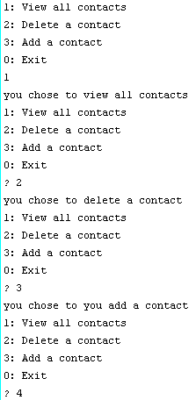

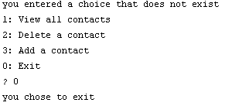

1. If you haven’t already – put your menu code (from previous question) into subroutine(s) that is/are called from main.
2. Store some contact names in an Array– see which of the menu options you can get to work